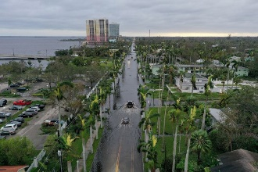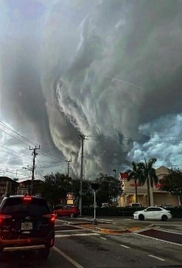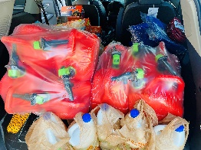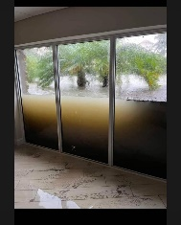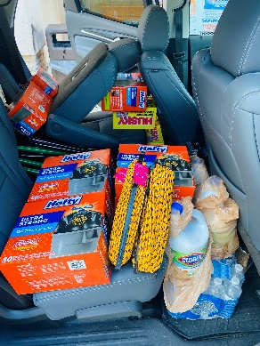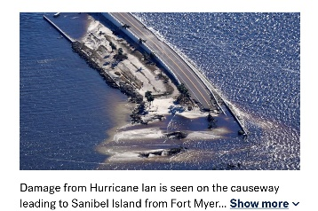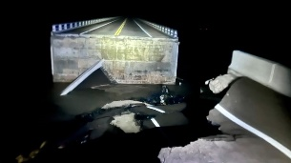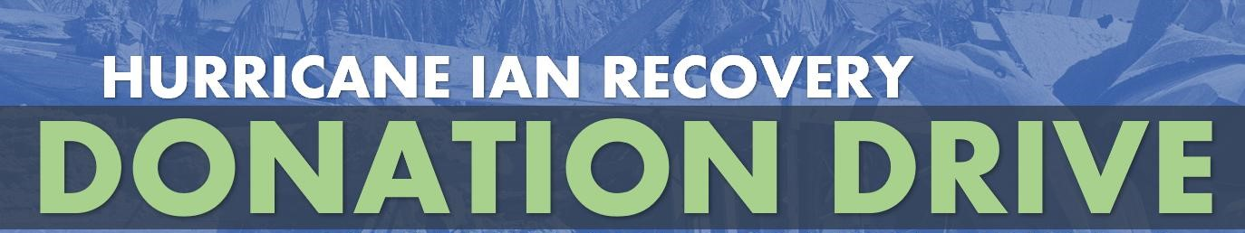

OCTOBER 06, 2022

HURRICANE IAN CAUSED AN ENORMOUS AMOUNT OF DEATH AND DESTRUCTION ON THE FLORIDA WEST COAST.

THE DAMAGE INFLICTED BY THIS HORRIFIC HURRICANE IS BEYOND COMPREHENSION. WE MUST HELP OUR FELLOW FLORIDIANS, SUFFERING SO MUCH AFTER THIS HORRIBLE TRAGEDY.

THOSE OF US WHO HAVE GONE THROUGH SIMILAR CATASTROPHIC EVENTS KNOW THE FEELING OF HOPELESSNESS AND DESPAIR AFTER LOSING OUR HOMES AND PRICELESS POSSESSIONS.

WE HAVE RECEIVED THROUGH OUR DISTRICT A LIST OF THE ITEMS THAT ARE MOST NEEDED AND IT IS VERY IMPORTANT TO SEND IT TO THEM AS SOON AS POSSIBLE. WE CAN COLLECT SUCH ITEMS THAT PERHAPS YOU HAVE AT HOME OR WE CAN RAISE FUNDS TO BUY THEM.

OUR BOARD APPROVED $1,000 IN MATCHING FUNDS FOR THE MONEY WE RAISE. OUR WONDERFUL PETER VERBEECK HAS ALREADY DONE THE FIRST ROUND OF SHOPPING. HE JUST TOOK $1,000 WORTH OF MUCH-NEEDED GOODS TO FORT MYERS. THANKS SO MUCH, PETER FOR VOLUNTEERING!

**PLEASE CONTRIBUTE AS MUCH AS YOU CAN. YOUR HELP IS NEEDED TO ALLEVIATE SO MUCH ANGUISH AND SUFFERING. LET’S SHOW OUR FELLOW FLORIDIANS THAT THERE IS HOPE AND THAT WE ROTARIANS CARE.**

**WE BOUGHT THIS.**

**WE NEED MORE**

**MORE**

* Tarps.
* Rope
* Sunscreen
* Mosquito Spray
* Bungle Cords
* Gas Cans
* Coolers
* Re-usable shopping bags
* Toilet Paper
* Paper plates
* Plastic Ware
* Paper Towels
* Gloves
* Clorox or disinfectants
* Cleaning Wipes
* Soaps and sanitizers
* Dust Masks
* Caps/Hats

**ITEMS LIST**